Planning Services
Gateway determination report

LGA | Liverpool City Council
PPA | Liverpool City Council
NAME | Liverpool LEP 2008 - Amendment 74 - To allow multi dwelling housing as additional use – 123 Epsom Road, Chipping Norton (2 or more dwellings, 0 jobs)
NUMBER | PP_2019_LPOOL_001_00
LEP TO BE AMENDED | Liverpool LEP 2008
ADDRESS | 123 Epsom Road, Chipping Norton
DESCRIPTION | Lot 3 DP 602936
RECEIVED | 8 April 2019
FILE NO. | IRF19/2581
POLITICAL DONATIONS | There are no donations or gifts to disclose and a political donation disclosure is not required.
LOBBYIST CODE OF CONDUCT | There have been no meetings or communications with registered lobbyists with respect to this proposal.
1. INTRODUCTION
1.1 Description of the planning proposal
The planning proposal (Attachment A) seeks to amend the Liverpool Local Environmental Plan (LLEP) 2008 – Schedule 1 Additional permitted uses to permit ‘multi dwelling housing’ as an additional permissible use with consent on land zoned R2 Low Density Residential. No other existing development controls are proposed to be changed. The proposal would provide for 6 new homes.
1.2 Site description
The planning proposal relates to land at 123 Epsom Road, Chipping Norton, Liverpool (Lot 3 DP 602936) on the south-east corner of Epsom Road and Governor Macquarie Drive. The site contains a large two-storey dwelling with a swimming pool and a tennis court within the rear yard (Figures 1 and 2). The total area of the site is approximately 2,209 m².
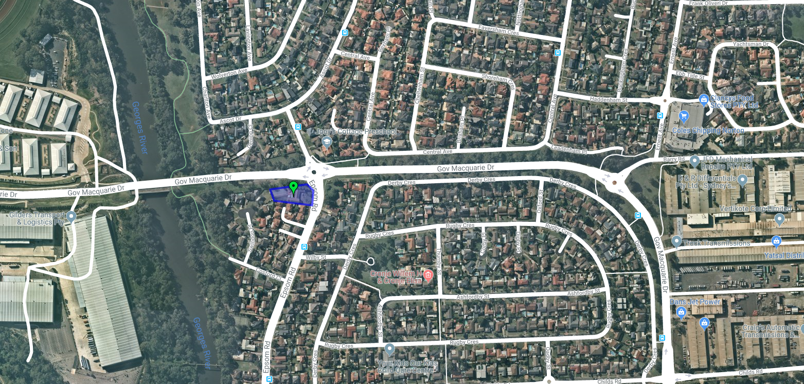
Figure 1: Aerial view of 123 Epsom Road, Chipping Norton, Liverpool (outlined in blue) and immediate surrounds (source: Nearmap).
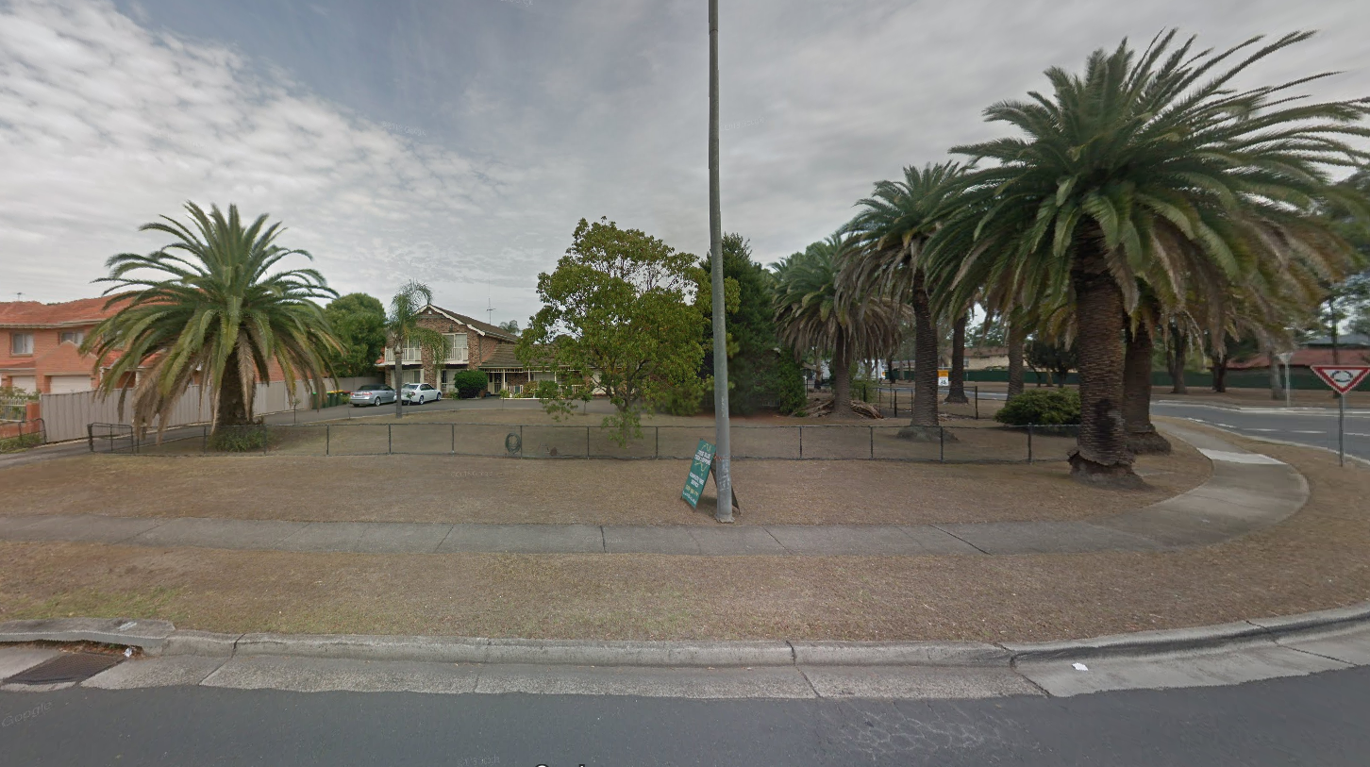
Figure 2: View along Epsom Road looking towards the site- Front elevation of 123 Epsom Road.
1.3 Existing planning controls
The following development standards apply to the site under LLEP 2008:
- R2 Low Density Residential zoning;
- Maximum building height of 8.5m; and
- Maximum FSR of 0.5:1.
Maps in Figures 3-5 shows the current controls from the LLEP 2008.
R2 zone in the LLEP 2008 does not allow ‘multi dwelling housing’. The site was zoned Low Density Residential under the previous LEP (LLEP 1997) and ‘multi dwelling housing’ was permissible with consent on the site.
The site is not located within a heritage conservation area. However, a row of locally significant heritage listed Palm Trees (Phoenix canariensis) are located within the north-eastern corner of the site (Figures 6-8).
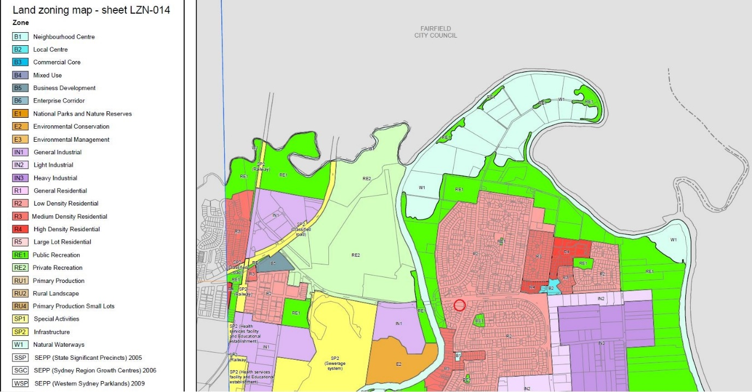
Figure 3: Land zoning map, with the subject site (outlined with a red circle) and the surrounding area - zoned R2 Low Density Residential (pink), zoned R3 Medium Density Residential (dark pink), and RE1 Public Recreation (green) further to the south-east of the site (source: LLEP 2008 land zoning maps)
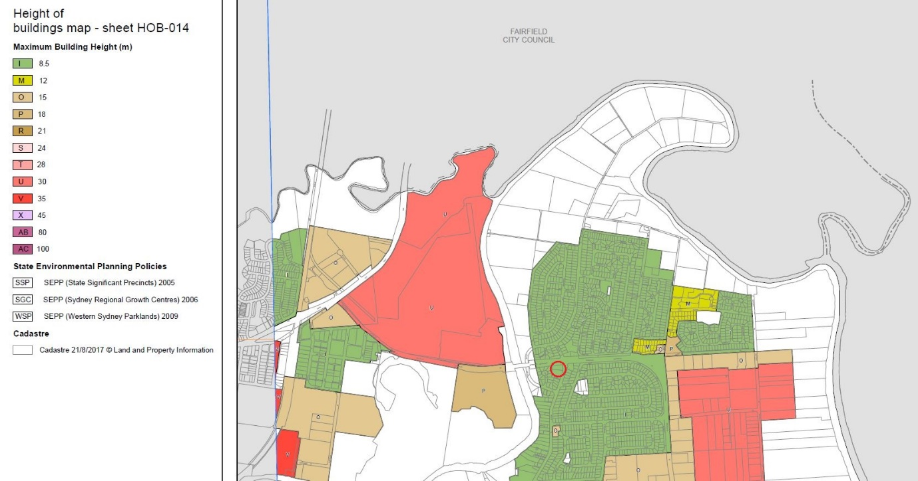

Figure 4: Existing maximum height of the building – 8.5m - highlighted with a red circle (source: LLEP 2008 HOB maps)
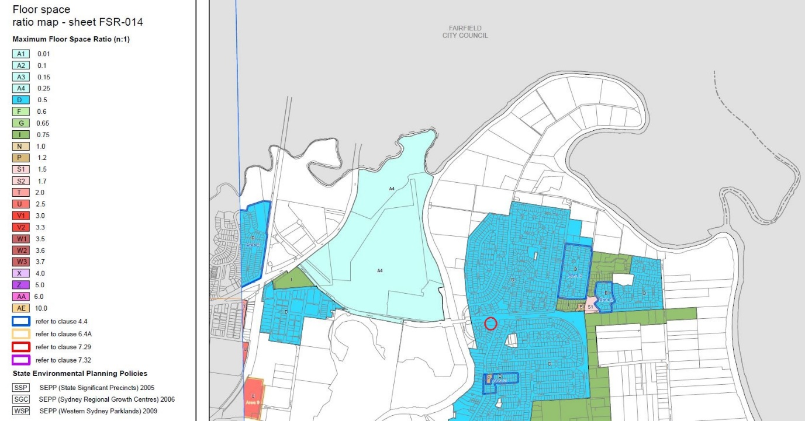
Figure 5: Existing FSR of 0.5:1 over the site - highlighted with a red circle (source: LLEP 2008 FSR map)

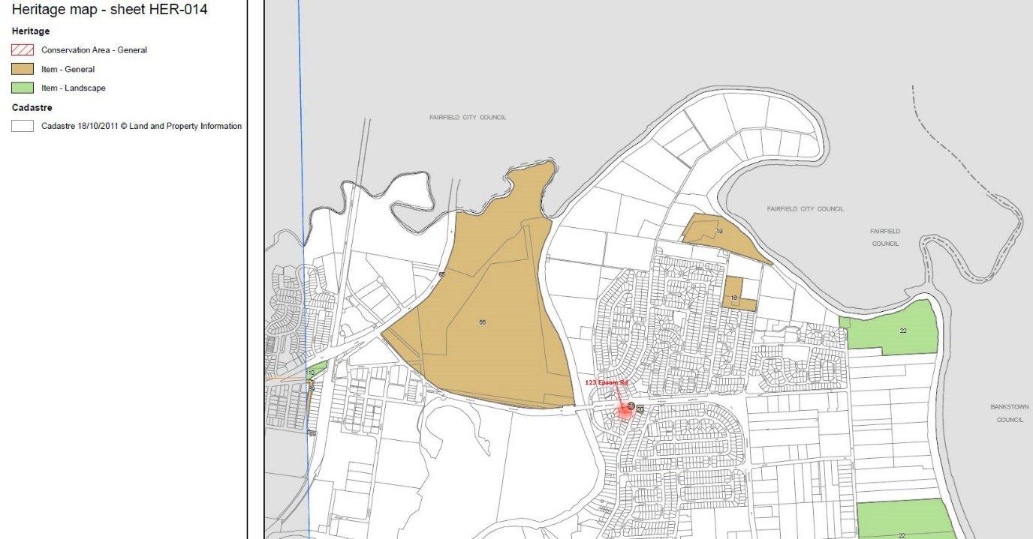
Figure 6: Existing Heritage map (source: LLEP 2008 Heritage map)
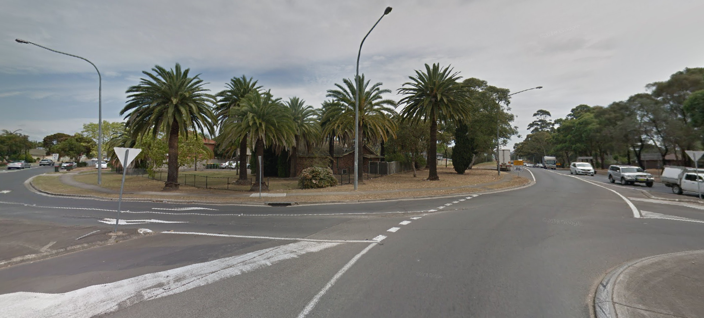
Figure 7: Corner of Epsom Road and Governor Macquarie Drive looking towards heritage listed palm trees

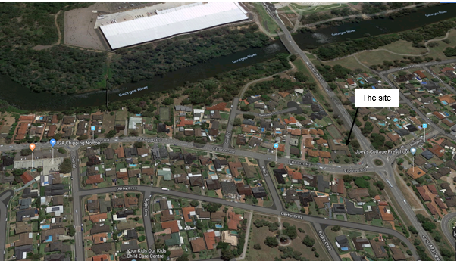
Figure 8: Surrounding area

1.4 Surrounding area
The site is in Chipping Norton in a suburban setting surrounded predominantly by low-density residential development with some secondary dwellings and ‘multi dwelling housing’. The surrounding area including the adjoining site to the south (125 Epsom Rd) has several ‘multi dwelling housing’ developments that were approved under the previous LLEP 1997.
1.5 Summary of recommendation
It is considered that the planning proposal is suitable to proceed to Gateway
determination for the following reasons:
- the size and the nature of the subject site is capable of accommodating ‘multi dwelling housing’ development;
- the site is located within walking distance of the local shops, parks and is connected to Liverpool City Centre by public transport and will make efficient use of existing infrastructure and services;
- no existing development controls are to be changed;
- the proposal will provide additional housing supply to support the Council’s growing population challenge while maintaining the existing residential character of the area;
- the proposal is consistent with relevant Objectives and Planning Priorities of the Greater Sydney Region Plan, Western Sydney District Plan and Liverpool Community Strategic Plan in terms of increasing housing opportunities; and
- the proposal is of a minor nature for an individual site, and is unlikely to pre-empt or prejudice the strategic outcome of the local housing strategy which is being prepared by Council.

2.1 Objectives or intended outcomes
The objective of the planning proposal is to allow the development of ‘multi dwelling housing’ at 123 Epsom Road, Chipping Norton as an additional permissible use with consent on land zoned R2 Low Density Residential through an amendment to Schedule 1 Additional permitted uses of the LLEP 2008.
2.2 Explanation of provisions
The planning proposal will amend Schedule 1 Additional permitted uses of the Liverpool LEP 2008 to include an additional clause that applies explicitly to 123 Epsom Road, Chipping Norton. This proposed amendment will allow for ‘multi dwelling housing’ on the subject site as an additional permissible use with development consent on the site.
No detailed plans have been submitted with the proposal. The proposal does not seek to rezone land or amend the existing controls.
2.3 Mapping
The planning proposal proposed to amend the Key Sites Map of the LLEP (4900_COM_KYS_014_020_20180730) as shown in Figure 9 below. The proposed map amendment is not required as the proposal applies to the entire site.
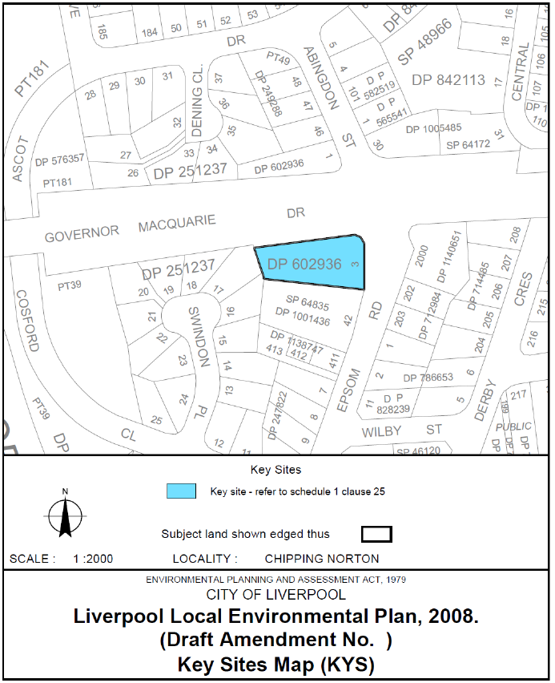
Figure 9: Liverpool LEP 2008 mapping – proposed amendments to the Key Sites Map (4900_COM_KYS_014_020_20180730).
3. BACKGROUND

In December 2018, Council resolved to support the landowner’s request and prepare a planning proposal.
In February 2019, the Liverpool Local Planning Panel (LLPP) recommended (Attachment D) Council defer a decision on the planning proposal until the Local Housing Strategy (LHS) is finalised and adopted by Council. The Panel was concerned that:
- a decision to change the permitted use on this site in isolation is premature considering the upcoming review of the Liverpool LEP 2008, a component of which will be informed by the Local Housing Strategy (LHS).; and
- Council should be mindful not to pre-empt or prejudice the outcome of the strategy in relation to this site. Until the strategy is finalised, the Panel is not confident in recommending that the planning proposal has strategic merit.
At the time Council informed the Panel that the LHS will be finalised imminently. It should be noted that the Liverpool LHS will not be finalised before July 2019.
- On 27 March 2019, Council noted the Panel’s advice and resolved to support the proposal proceed to Gateway for the following reasons (Attachment E):
- the proposal has strategic and site-specific merit;
- the proposal is site specific and will not undermine the strategic planning framework;
- the site is relatively large and can accommodate, subject to development consent, an appropriate ‘multi dwelling housing’ development;
- the surrounding development is consistent with that proposed for the site; and
- the historical land use zoning that applied to this site which permitted ‘multi dwelling housing’.
4. NEED FOR THE PLANNING PROPOSAL
This planning proposal is not the result of any strategic studies or reports. It was initiated in response to landowner requests. Council resolved to prepare the planning proposal in December 2018.
The existing R2 zone in the LLEP 2008 does not allow ‘multi dwelling housing’. The site was zoned Low Density Residential under the previous LEP (LLEP 1997) and allowed ‘multi dwelling housing’ with consent on the site.
The proposed amendment to Schedule 1 Additional permitted uses will allow the development of ‘multi dwelling housing’ on the site (2,209 m²) without the need for rezoning and changes to the existing development controls. It is considered that the planning proposal is the best means to achieve the intended outcome.
5. STRATEGIC ASSESSMENT
5.1 Regional and District Strategic Plans
5.1.1 Greater Sydney Region Plan: A Metropolis of Three Cities
The Greater Sydney Region Plan was released by the Greater Sydney Commission
on 18 March 2018. It provides a 40-year vision for Greater Sydney and is designed
to inform district and local plans and the assessment of planning proposals.
The proposal is generally consistent with the plan’s liveability objectives and actions, in particular with:
- Objective 7: Communities are healthy, resilient and socially connected;
- Objective 10: Greater housing supply
- Objective 11: Housing is more diverse and affordable
- Objective 13: Environmental heritage is conserved and enhanced.
The planning proposal intends to deliver new and diverse housing, respond to housing demands within the Chipping Norton locality and make efficient use of existing infrastructure and services. The site contains a landscape heritage listed item (palm trees) which will be conserved and managed. The proposed development is also located within walking distance to open spaces, local centres and shops that supports healthy, resilient and socially connected communities.
5.1.2 Western City District Plan
The Western City District Plan was released on 18 March 2018. The plan contains planning priorities and actions to guide the growth of the Western City District while improving the district’s social, economic and environmental assets.
The proposal is consistent with the following priorities of the Western City District Plan:
- Planning Priority W5: Providing housing supply, choice and affordability, with access to jobs, services and public transport:
  - Objective 10: Greater housing supply; and
  - Objective 11: Housing is more diverse and affordable.
- Planning Priority W6: Creating and renewing great places and local centres, and respecting the District’s heritage:
  - Objective 12: Great places that bring people together; and
  - Objective 13: Environmental heritage is identified, conserved and enhanced.
The proposal is consistent with the liveability planning priorities under the District Plan. The outcome of the proposal will enable new housing diversity and choice in the locality. The site is located within walking distance of the local shops, parks and services that engage and connect people and communities. The local heritage listed palm trees will be conserved and managed in accordance with clause 5.10 Heritage conservation.
The Department is satisfied that the planning proposal gives effect to the District Plan in accordance with section 3.8 of the Environmental Planning and Assessment Act 1979.
5.2 Local
4.2.1 Liverpool Community Strategic Plan – Our Home, Liverpool 2027
Our Home, Liverpool 2027, has been prepared by Council through extensive community consultation to give strategic planning directions to Council and stakeholders. Council has advised that the planning proposal is consistent with the Liverpool Community Strategic Plan. It will support the Council’s growing population challenge while maintaining the character of the R2 Low Density Residential Zone.

5.2.2 Liverpool Residential Development Strategy 2008
The subject site is not located within the identified area of the Liverpool Residential Development Strategy (Figure 9). However, it aligns with the strategy to locate medium density residential within 200m-800m of a local centre and major transport nodes.
The proposed development is approximately 863m walking distance (through footpaths) to the Chipping Norton local centre with access to public transport to Liverpool city centre.
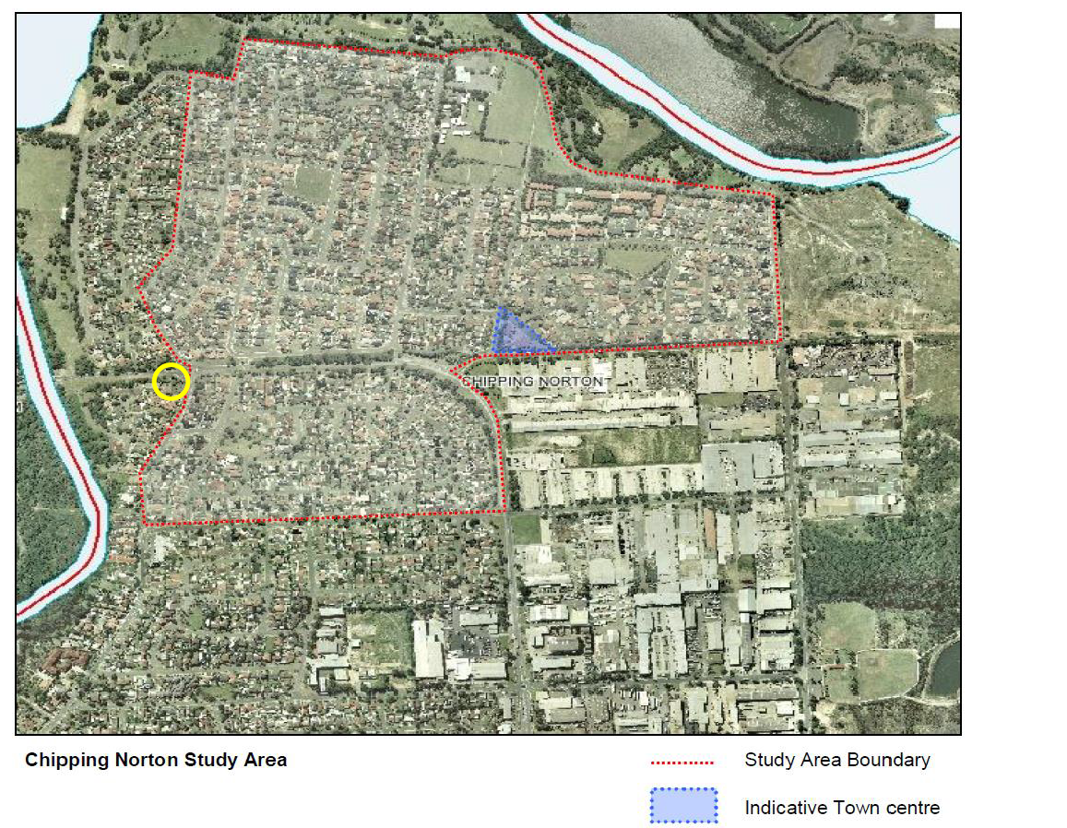
Figure 9: Chipping Norton Residential Land Study Map – the subject site highlighted with a yellow circle (source: the proposal).
5.3 Section 9.1 Ministerial Directions
The relevant Section 9.1 Directions are as follows:
Direction 2.3 Heritage Conservation
The objective of this Direction is to conserve items, areas, objects and places of environmental heritage significance and indigenous heritage significance.
This Direction applies to the proposal as the site contains a row of locally significant heritage listed palm trees.

However, it is considered that these trees are already conserved under the existing LLEP 2008 as per clause 5.10 Heritage conservation and can be appropriately addressed at development approval stage. It is considered that the proposal is consistent with this Direction.
Direction 3.1 Residential Zones
The objectives of this Direction are to encourage a variety of housing types, make
efficient use of existing infrastructure and services, ensure new housing has
appropriate access to infrastructure and services, and minimise the impact of
residential development on the environment and resource land.
This Direction applies to the proposal as the planning proposal will affect land within the residential zone. The proposal is considered consistent with this Direction as:
- the site is currently occupied by a large single dwelling and has access to basic infrastructure (water, sewage, electricity etc), road network and a limited bus services to Liverpool city centre;
- the proposal will encourage an increase in housing supply and diversity in the locality; and
- the site is relatively small in scale with minimum impact on public infrastructure provision.
Direction 4.1 Acid Sulfate Soils
The objectives of this Direction are to avoid significant adverse environmental impacts from the use of land that has a probability of containing acid sulfate soils.
This Direction applies to the proposal as the subject site is mapped as having Class 5 acid sulfate soils under LLEP 2008.
Clause 7.7 Acid sulfate soils of LLEP 2008 will apply and is a matter that can be addressed at the development application stage in accordance with the requirements of the clause. The clause requires an acid sulfate soils management plan to be submitted at the development application stage, if certain development thresholds are met.
The proposal is consistent with this Direction.
Direction 4.3 Flood Prone Land
The objectives of this Direction are to ensure that development of flood prone land is consistent with the NSW Government’s Flood Prone Land Policy and the principles of the Flood plan Development Manual 2005, and to ensure that the provisions of an LEP on flood prone land is commensurate with flood hazard and includes considerations of the potential flood impacts both on and off the subject land.
This Direction is relevant to this proposal as the site is identified as flood prone land with low flood risk and within the Probable Maximum Flood. The site is above the 1 in 100-year flood level and the flood planning area which is 1 in 100-year flood level plus 0.5m freeboard where risk and damages are very low for most land uses. Council’s flooding advice has confirmed that the property is above the flood planning level.
It is recommended that the Secretary’s delegate agree that the inconsistency with this Direction is of minor significance.
Direction 6.3 Site Specific Provision
The objective of this Direction is to discourage unnecessary restrictive site-specific planning controls.
This Direction applies to the planning proposal as it includes a site-specific provision in Schedule 1 of the LLEP 2008 to allow the development of multi-dwelling housing land use in the existing R2 Low-Density Residential Zone. This clause will only apply to this land and will not apply and have no impact on the broader low density residential areas.
It is considered the proposal is consistent with this Direction as it does not involve unnecessarily restrictive site-specific planning controls.
5.4 State environmental planning policies (SEPPs)
The planning proposal is not inconsistent with any applicable SEPPs or deemed SEPPs.
6. SITE-SPECIFIC ASSESSMENT
6.1 Social/Economic
The proposal aims to retain the existing low-density character of the R2 zone and ensure the development remains consistent with the existing level of access to social and utility infrastructure.
The development ‘multi dwelling housing’ via the proposal will not create adverse social and economic impacts. It will enable additional diverse housing within the locality. The site also has sufficient access to nearby schools within the Chipping Norton, Moorebank, Warwick Farm and Georges Hall suburbs.
6.2 Environmental
There are no known critical habitats, threatened species or ecological communities that would be impacted by the proposal.

Heritage

The site contains a row of locally significant heritage listed palm trees. The proposal does not include any provisions to facilitate the conservation of these trees, however, clause 5.10 Heritage Conservation of the existing LLEP 2008 includes requirements and head of considerations to be considered by the proponent and Council at development stage and is considered satisfactory.
The proposal does not contain any heritage assessment report. Council resolution recommended a heritage impact assessment report to be prepared in consultation with the NSW Office of Environment and Heritage – Heritage Division (Attachment E). A Gateway condition has been proposed requiring a heritage impact assessment report to be prepared prior to community consultation and consultation with NSW Office of Environment and Heritage – Heritage Division.
Acid sulfate soils
The subject site is mapped as having Class 5 acid sulfate soils under LLEP 2008. An acid sulfate soils study has not been submitted with the planning proposal to support the intensification of development. Council advises if future development sought the construction of any basement level parking or the like, an Acid Sulfate Soils Study is required and recommended for a study to be prepared as part of the Gateway condition. A Gateway condition has been proposed requiring an acid sulfate soils study prior to community consultation.
6.3 Infrastructure
Community infrastructure
The site is not located within 800m of major transport node. However, it is in a walkable distance of the local centre and close to several local parks such as South Park, Angle Park and Black Muscat Park. The Liverpool city centre on the western banks of the George River is located within 30 minutes from the subject site by public transport. There is a bus stop close to the site along Governor Macquarie Drive that provides a limited bus service to Liverpool city centre (one bus every 30 minutes during peak hour). This will provide access to major retail/business, community services and recreational activities.
Service infrastructure
The currently occupied dwelling has sufficient access to infrastructure and services. However, due to the lack of detailed information and uncertainty about future development, Council requires an Infrastructure Services report to be prepare through consultation with relevant public authorities to ensure new dwellings will be adequately serviced. Council has advised that the Infrastructure Services report should include servicing strategies to address services strategies for water supply, sewerage and electricity supply, natural gas and telecommunication in accordance with the potential yields facilitated by the planning proposal. This is a matter that can be addressed at development application stage.
A Gateway condition has been proposed for consultation with relevant service providers including Sydney Water, Endeavour energy and Telstra.
Traffic
The site is a corner allotment with a primary frontage to Epsom Road and a secondary frontage to Governor Macquarie Drive. Council recommended that a Traffic Impact Assessment to be prepared to address issues such as access, impact on the road network and intersections, driveways, pedestrian crossing points and parking issues. A requirement to prepare a Traffic Impact Assessment as well as consultation with RMS has been inserted in the Gateway conditions to address these issues.
7. CONSULTATION
7.1 Community
The planning proposal is of a low impact in nature. Community consultation is proposed by Council for 14 days, which is considered appropriate.
7.2 Agencies
The planning proposal proposed to consult with the NSW Office of Environment and Heritage – Heritage Division and RMS.
It is recommended that Council consult with the following additional agencies:
- Sydney water;
- Endeavour Energy;
- Telstra; and
- other relevant service providers.
8. TIME FRAME

The Council’s request for timeframe to finalise this planning proposal is six months from the date of the Gateway determination. The Department recommends 12 months to finalise the plan to allow sufficient time to prepare required studies as recommended in this report.

9. LOCAL PLAN-MAKING AUTHORITY
Council has not requested the use of plan making delegations. Given the local nature of the proposal, authorisation is to be given to Council to finalise the proposal.
10. CONCLUSION
The planning proposal is supported to proceed with conditions as it is of a minor nature and will facilitate housing supply within the Liverpool LGA, and would have a positive social and economic impact for the area.
11. RECOMMENDATION
It is recommended that the delegate of the Secretary:
- agree that any inconsistency with section 9.1 Direction 4.3 Flood Prone Land is of minor significance.
It is recommended that the Director, Sydney Region West, Planning Services, as delegate of the Minister for Planning, determine that the planning proposal should proceed subject to the following conditions:
- Prior to community consultation:
  - Council is required to undertake the following studies to support the proposal as follows:
    - a Heritage Impact Assessment study to address heritage constraints and potential impacts of future development;
    - Traffic Impact Assessment study to address potential impacts and improvement to the existing road network; and
    - an Acid Sulfate Soils study.
  - Council is to update the planning proposal, if required, consistent with the outcomes of the studies referred in part (a);
  - Council is to update the planning proposal to remove the Key Sites Map as it is not considered required; and
The revised planning proposal and completed studies are to be forwarded to the Department for review and approval.
- Community consultation is required under Sections 3.34(2)(c) and Schedule 1, Clause 4 of the Environmental Planning and Assessment Act 1979 (the Act) as follows:
  - the planning proposal must be made publicly available for a minimum of 14 days; and
  - the planning proposal authority must comply with the notice of requirements for public exhibition of planning proposals and the specifications for material that must be made publicly available along with planning proposals as identified in Section 5.5.2 of A guide to preparing local environmental plans (Department of Planning and Environment 2016).

- Consultation is required with the following public authorities/organisations under section 3.34(2)(d) of the Act and/or to comply with the requirements of relevant section 9.1 Directions:
- NSW Office of Environment and Heritage – Heritage Division;
- Road and Maritime Services;
- Sydney water;
- Endeavour Energy;
- Telstra; and
- other relevant service providers.
Each public authority/organisation is to be provided with a copy of the planning proposal and any relevant supporting material and given at least 21 days to comment on the proposal.
- A public hearing is not required to be held into the matter by any person or body under section 3.34(2)(e) of the Act. This does not discharge Council from any obligation it may otherwise have to conduct a public hearing (for example, in response to a submission or if reclassifying land).
- The planning proposal authority is authorised as the local plan-making authority to exercise the functions under section 3.36(2) of the Act subject to the following:
  - the planning proposal authority has satisfied all the conditions of the Gateway determination;
  - the planning proposal is consistent with section 9.1 Directions or the Secretary has agreed that any inconsistencies are justified; and
  - there are no outstanding written objections from public authorities.
- The timeframe for completing the LEP is to be 12 months from the date of the Gateway Determination.

14/05/2019

Cho Cho Myint Ann-Maree Carruthers
Senior Planner, Sydney Region West Director, Sydney Region West,
Planning Services Planning Services

Assessment officer: Parisa Pakzad
Sydney Region West
Phone: 9860 1584

